CPS842 Movie Rater Recommender System

Sundar Murugesan 50015649 | Richard Hong Nguyen 500385624

## User Based Collaborative Filtering

## Introduction

For this project, we decided to create and implement a website-based movie recommender system that has user based collaborative filtering, i.e. the system will recommend a movie to a user based on other user ratings on the same movie. The similarity is calculated via the Pearson Correlation Coefficient, the one we used is an algebraic variant which allows for a single pass versus a multi-pass calculation. The environment/languages we used are PHP and MySQL.

## How the System Works

Working example: <http://www.sundarmurugesan.ca/richard/>

* User arrives to the splash screen or login page, they can either log in if they already have an account or create a new account
* User is brought to the home page, here it will display navigational links to rate movies or to log out. The movies (if any) that were rated in the past will be displayed as well as recommendations if enough data is collected from the user.
* If the User clicks on ‘Rate Movies’, it will bring them to a page with a simple selection form with movies populated from the database. After submitting the rating to the movie, the information will be processed and passed to the database and perform calculations
* To see the raw data that is calculated, click on ‘See Raw Data’ else click on ‘Back to Home’ and if enough information is collected, it will display a recommendation to the user.

## Files Included:

Website Files:

* dbconfig.php: contains the database login information
* detail.php: displays the raw data used to calculate recommendations
* display.php: displays some information about the current logged in user, i.e. userid, name, the movieid and rating that was passed from the form and it displays similar user ids that have rated similar movies. it contains all of the SQL queries required to do the calculations of user similarity
* home.php: home page of the movie rater site, displays movies rated by the user in the past and will display recommendations based on other user ratings if enough information is collected
* index.html: the login page
* logout.php: will process the user logging out and terminates all sessions
* processlogin.php: processes the login information given by index.html, will give an error if account credentials are incorrect
* processsignup.php: processes the new user information from signup.php, will give an error if username already exists
* rate.php: allows a user to select from a form which movie they would like to rate, if a movie has been rated before it allows them to update their rating.
* signup.php: allows a new user to input account information for creation of a new account on the system
* style.css and contents of img folder, just for style purposes

SQL Files:

* CreateTables_MovieRecommender.sql: Creates the tables for the database schema for the recommender system
* findListOfMoviesNotSeenByUserLoggedIn.sql
* findPredictedUserRating.sql
* findSimilarUsersPearsonCoefficients.sql

**N.B.** The queries here have to be slightly modified in order to work with general cases.

Misc. Files:

* MovieRecommenderSampleData.xls
* MovieRecommenderSchema.jpg: Overview of the DB Schema
* Flowchart.png

Functions Used:

* Pearson Correlation Coefficient (Variant)

$r = \frac{\sum_{i=1}^{n}{x_{i}y_{i}-\frac{\sum_{i=1}^{n}{x_{i}{ \sum_{i=1}^{n}{y}}_{i}}}{n}}}{\sqrt{\sum_{i=1}^{n}{x_{i}^{2}}-\frac{({\sum_{i=1}^{n}{x_{i}})}^{2}}{n}}\sqrt{\sum_{i=1}^{n}{y_{i}^{2}}-\frac{({\sum_{i=1}^{n}{y_{i}})}^{2}}{n}}}$

* Weighted-Sum

$r_{c,s}= k\sum{sim\left(c,c^{'}\right){×r}_{c^{'}s}} where k=1/\sum_{c^{'}∈\hat{c}}{|sim(c,c^{'})}$

Database Schema

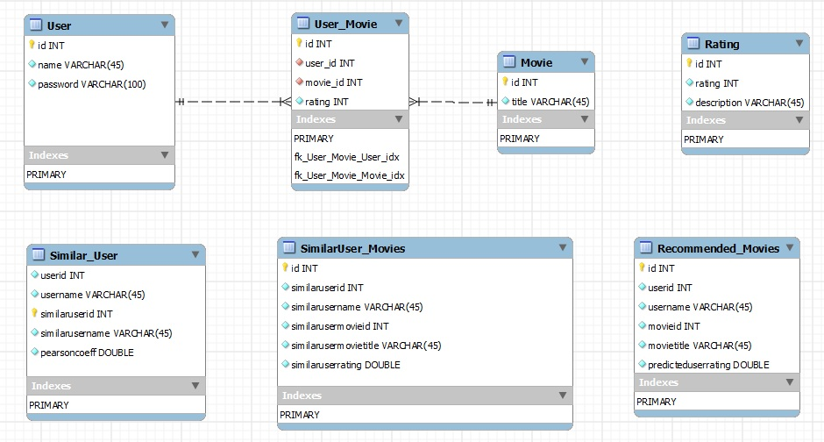

## Flow Chart of System Architecture

